# ACCOUNT ACTIVATION

New users will receive an email similar to the one below with a link to set up security questions and choose a password. Click on the link to begin account activation.

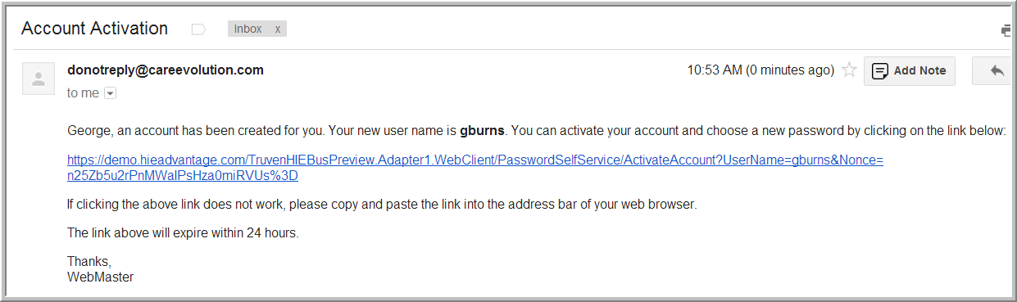

Choose a password. Click the arrow beside **What makes a strong password?** to view the requirements for your system. Enter your password and confirm, then click **Submit**.

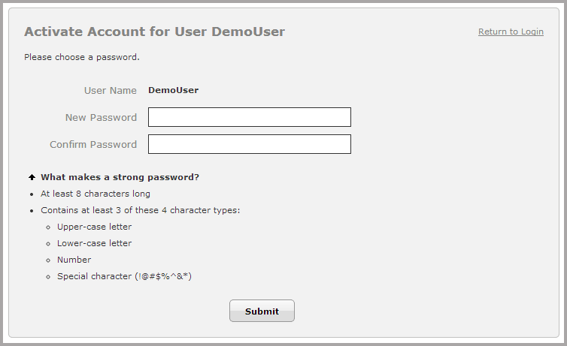

After your new password is accepted, you will see a confirmation screen. Make note of your user name before proceeding(the user name is “gburns” in the example below). Select **Click here to login**.

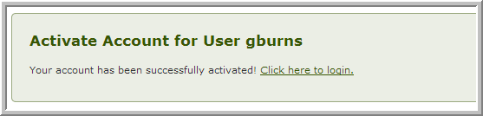

You will be taken to the login screen. Enter your username and password and click the **Login** button.

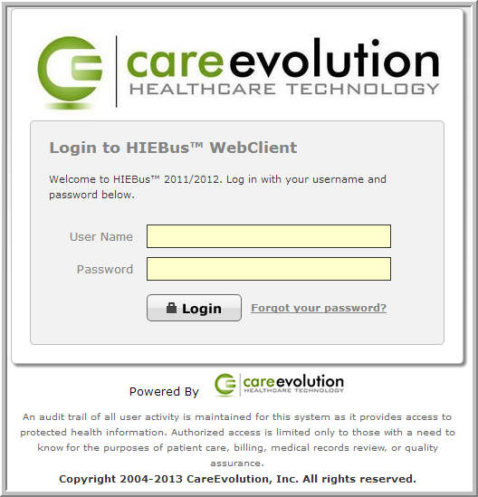

If you attempt login using the incorrect password too many times, your account will become locked out. Locked accounts will become unlocked after a certain amount of time. If you are having difficulties logging into your account, click the **Forgot your password?** link, or contact your system administrator.

Follow the directions to add at least three security questions. You may edit these later by clicking **My Profile** at the top of the Application Dashboard page.

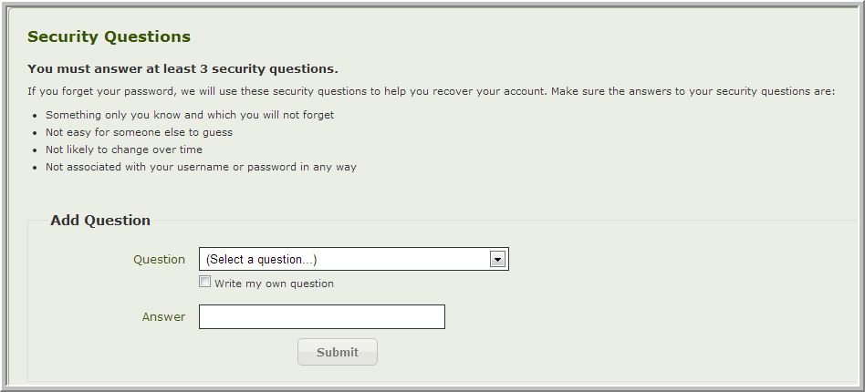

After adding your third security question, you will be redirected to the Application Dashboard.